**Cangames 2024**

presents

Cassandra in the Lair of Despair

The massive roar of the underground waterfall left behind, a steaming lake of sulfurous water fading into the dimness ahead, illuminated by faint glowing sparks shining down from upon high. The water stirs and swirls, as if alive – can hope still remain for Cassandra and her unquenchable comrades?

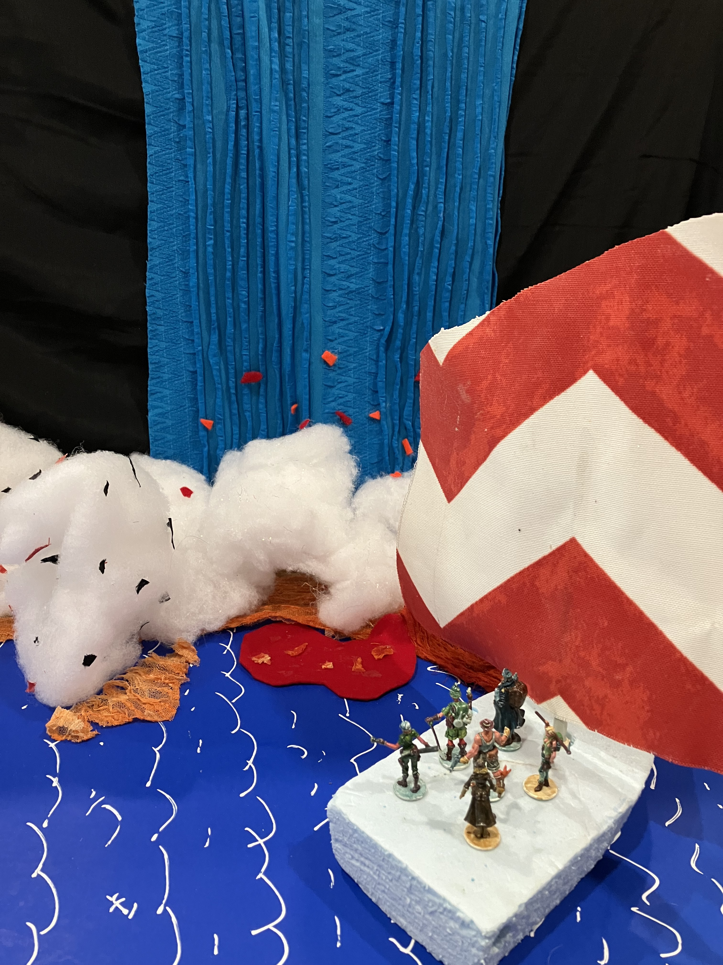

**Can Cassandra Trimble Survive the Dreaded Lair of Despair?**

Carefully scouring the submerging rocky crags, springing from one slippery surface to the next as the boiling water rises, Katrina Ananova and her steadfast companions discover a hidden passage down into the depths. Fleeing along narrow ledges, they escape to a long, tortuous series of caverns, leading to a waterfall inhabited by giant prehistoric flying reptiles, cascading down from their cave into total darkness. Beyond, a dangerous sulfur-filled passage, a rampaging stream, and another series of rat-infested tunnels lead to the mysterious Mines of Mayhem, only their teamwork and determination helping them survive its ravenous inhabitants. At last, they reach the base of another waterfall, the Master of Misery standing imperiously at its top, commanding his minions to the attack. And, as fate would have it, he is defeated, allowing them to climb the falls and arrive at the shore of a vast underground lake, its farthest reaches obscured by thick clouds of steam that glow an ominous orange. The water’s surface swirls and ripples menacingly, scintillating crystals on the walls of the cavern lending a sickly illumination. Can Umberto keep up the party’s spirits and capture one final reel of footage before their doom arrives? Will Eric’s instincts once again guide them past creatures that might otherwise consume them? Or will Jane’s intrepid investigation lead to yet another hidden threat, lurking in wait, ready to make this the final adventure of our intrepid team?

AXIAL EVOLUTION PICTURES

Presents

**Cassandra in the Lair of Despair**

OR

**Journeys of Cassandra Through the Well of Eternity**

**Starring**

**Katrina Ananova** as Cassandra Trimble

**Tyrone Albertson** as Alex Travers

**Eric Van Daman** as Roger de Groot

**Galena Perez** as Mona Gutierez

Written and Directed by the man who brought you Terror of the Deep, Cassandra and the Mountain of Doom, Perils of Cassandra in the Lost World, Cassandra and the Elemental Abyss, Cassandra and the Tesseract of Time, Cassandra and the Chasm of Chaos, Cassandra on the Road to Nowhere, Adventures of Cassandra in the Mountains of Magic, and Cassandra in the Mines of Mayhem…

**Umberto Diaz**

IN THEATERS DECEMBER 1944

Hollow Earth Expedition “Perils of Cassandra” – Cast of Characters

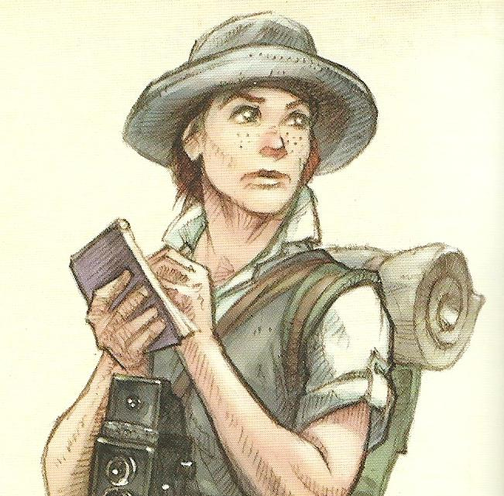

1. Jane Evans (American, Texas) – Intrepid Reporter, always nosing around looking for a scoop, intent on a big story today as the latest picture starring Katrina Ananova takes live shooting to the danger zone.

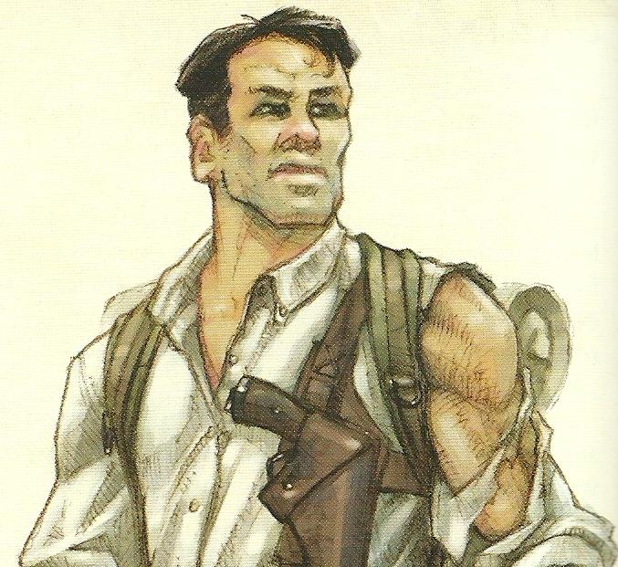

1. Tyrone Albertson (Australian) – Rugged Explorer, turned movie star. Tyrone is a seasoned veteran of the wilderness, tough and unyielding, a wooden actor at best but with the looks needed for his role as Katrina’s guide on this perilous picture.
2. 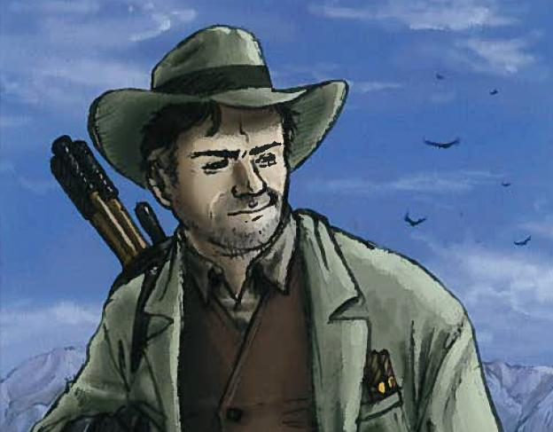Umberto Diaz (Portuguese) – Writer, Director, and part-time actor, Umberto likes to take his actors to the edge, put them in the real situation, and see what turns up in front of the camera. He is not a man easily persuaded, and has a knack for talking people into things.
3. Galena Perez (Mexican) – Occult Investigator, the mysterious supporting lady, who may be after Tyrone or may just be searching for some strange spirit that lives within the mountain. More dangerous than she looks, she also has an acute and eerie sensitivity for the bizarre and the mystical.
4. Eric Van Daman (South African) – Field Biologist, a man entirely absorbed in the natural environment and its inhabitants, a reasonable actor who can hold his own in small character roles. As the supporting actor, he is usually sent in front whenever unknown animals appear, and Tyrone is fine with that – until there’s a fight.
5. Katrina Ananova (Russian) – Imperiled Actress, Katrina can actually take care of herself better than she lets on, but she is so used to living her standard role of a damsel in distress that she almost believes it. Katrina’s female magnetism is only outweighed by her seemingly unerring ability to attract every kind of danger, which suits her role perfectly.