**Cangames 2025**

presents

Cassandra on the Treacherous Trail

The deadly drama of dungeon and dragon finally behind them, Cassandra and her unquenchable companions creep cautiously forward into the dark, echoing passage, scrambling desperately over rocky rubble and slimy, slippery sputum, residue of the dragon’s breath. A deep, unsettling rumble shakes the ground, showering them with rocks from the shattered ceiling. And ahead, through the darkness, a sickly reddish glow flickers feebly, beckoning them forward. Can they finally find a way out of the mountain to safety?

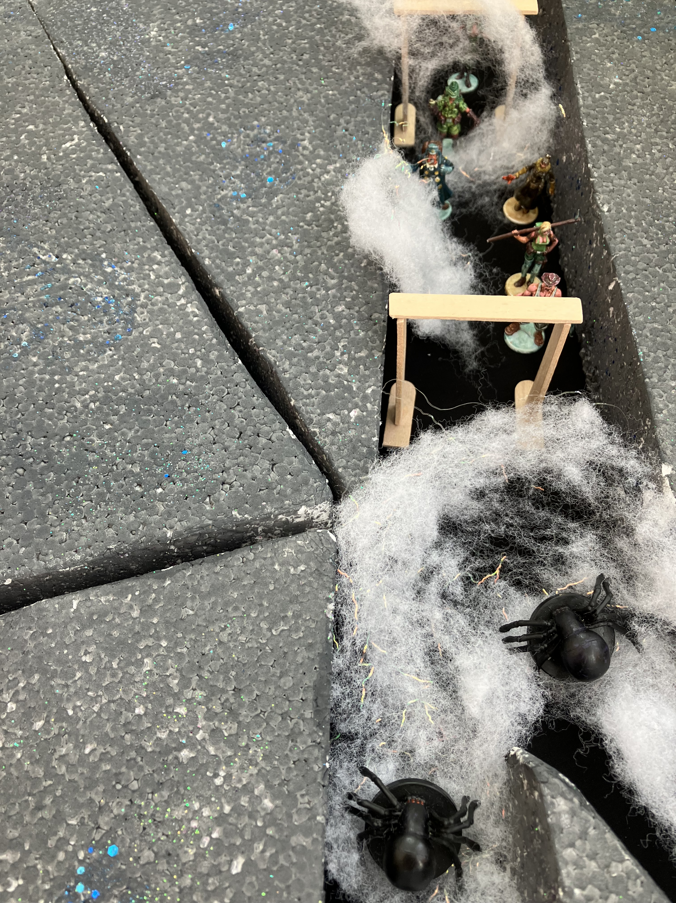

**Will Cassandra Trimble at last return to civilization?**

Scouring the shoreline of the ominous waters, Cassandra and her friends discover a rudimentary sailboat and set out onto the underground lake. Steam swirls on the far shore, an orange-red glow threatening unprecedented danger ahead. And from the waters below, giant slithering creatures assault the tiny craft, threatening to overturn it. Yet they persevere, sail through clouds of steam into the unknown, beneath the hissing waterfall. A series of branching caverns beyond the wall lead them at last, after many dangerous encounters, to a river of lava and another vertical rock wall. Bridging the fiery river they climb upwards, the smell of sulfur and ozone leading them forward to their fate. Further forks in the path and indomitable enemies nearly destroy their hope, but ingenuity and determination see them through to the bank of an underground stream – behind which a giant iridescent blue dragon looms. A battle of wills and deadly breath weapons finally leads them past the beast into the collapsed tunnel beyond. Can Umberto spur the group on to one more effort through the darkness? Will Eric once again persuade their animal enemies to grant them passage? Or will Cassandra’s natural knack for danger draw them into an inescapable trap, one which even Galena cannot see a way forward from?

AXIAL EVOLUTION PICTURES

Presents

**Cassandra on the Treacherous Trail**

OR

**Journeys of Cassandra Through the Trembling Tunnels**

**Starring**

**Katrina Ananova** as Cassandra Trimble

**Tyrone Albertson** as Alex Travers

**Eric Van Daman** as Roger de Groot

**Galena Perez** as Mona Gutierez

Written and Directed by the man who brought you Terror of the Deep, Cassandra and the Mountain of Doom, Perils of Cassandra in the Lost World, Cassandra and the Elemental Abyss, Cassandra and the Tesseract of Time, Cassandra and the Chasm of Chaos, Cassandra on the Road to Nowhere, Adventures of Cassandra in the Mountains of Magic, Cassandra in the Mines of Mayhem and Cassandra in the Lair of Despair…

**Umberto Diaz**

IN THEATERS DECEMBER 1945

Hollow Earth Expedition “Perils of Cassandra” – Cast of Characters

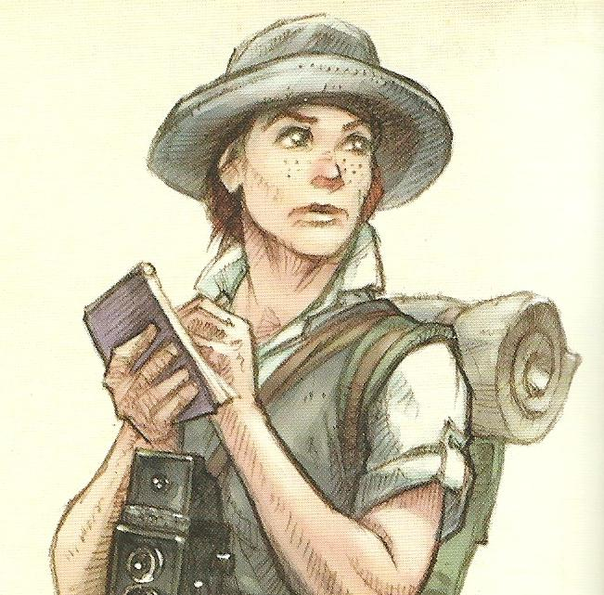

1. Jane Evans (American, Texas) – Intrepid Reporter, always nosing around looking for a scoop, intent on a big story today as the latest picture starring Katrina Ananova takes live shooting to the danger zone.

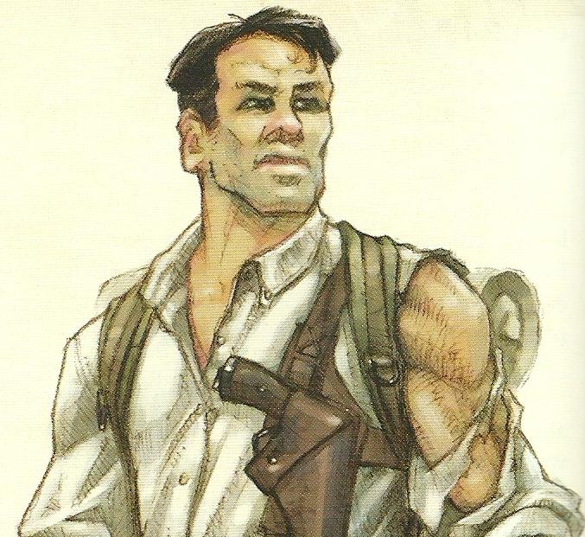

1. Tyrone Albertson (Australian) – Rugged Explorer, turned movie star. Tyrone is a seasoned veteran of the wilderness, tough and unyielding, a wooden actor at best but with the looks needed for his role as Katrina’s guide on this perilous picture.
2. 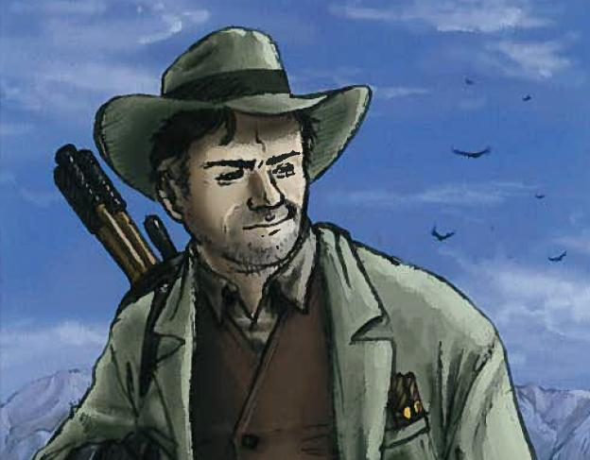Umberto Diaz (Portuguese) – Writer, Director, and part-time actor, Umberto likes to take his actors to the edge, put them in the real situation, and see what turns up in front of the camera. He is not a man easily persuaded, and has a knack for talking people into things.
3. Galena Perez (Mexican) – Occult Investigator, the mysterious supporting lady, who may be after Tyrone or may just be searching for some strange spirit that lives within the mountain. More dangerous than she looks, she also has an acute and eerie sensitivity for the bizarre and the mystical.
4. 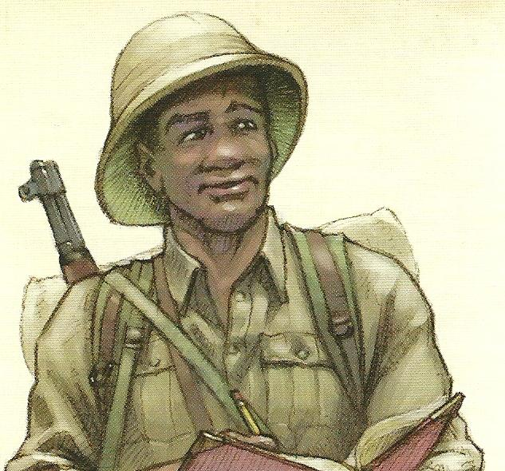Eric Van Daman (South African) – Field Biologist, a man entirely absorbed in the natural environment and its inhabitants, a reasonable actor who can hold his own in small character roles. As the supporting actor, he is usually sent in front whenever unknown animals appear, and Tyrone is fine with that – until there’s a fight.
5. Katrina Ananova (Russian) – Imperiled Actress, Katrina can actually take care of herself better than she lets on, but she is so used to living her standard role of a damsel in distress that she almost believes it. Katrina’s female magnetism is only outweighed by her seemingly unerring ability to attract every kind of danger, which suits her role perfectly.