Hollow Earth Expedition “Let’s Shoot That” – Cast of Characters

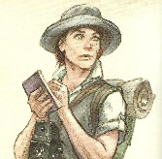

1. Jane Evans (American, Texas) – Intrepid Reporter, always nosing around looking for a scoop, intent on a big story today as the latest picture starring Katrina Ananova takes live shooting to the danger zone.

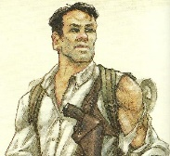

1. Tyrone Albertson (Australian) – Rugged Explorer, turned movie star. Tyrone is a seasoned veteran of the wilderness, tough and unyielding, a wooden actor at best but with the looks needed for his role as Katrina’s guide on this perilous picture.
2. 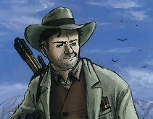Umberto Diaz (Portuguese) – Writer, Director, and part-time actor, Umberto likes to take his actors to the edge, put them in the real situation, and see what turns up in front of the camera. He is not a man easily persuaded, and has a knack for talking people into things.
3. 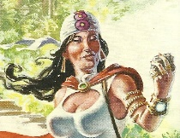Galena Perez (Mexican) – Occult Investigator, the mysterious supporting lady, who may be after Tyrone or may just be searching for some strange spirit that lives within the mountain. More dangerous than she looks, she also has an acute and eerie sensitivity for the bizarre and the mystical.

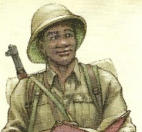

1. Eric Van Daman (South African) – Field Biologist, a man entirely absorbed in the natural environment and its inhabitants, a reasonable actor who can hold his own in small character roles. As the supporting actor, he is usually sent in front whenever unknown animals appear, and Tyrone is fine with that – until there’s a fight.



1. Katrina Ananova (Russian) – Imperiled Actress, Katrina can actually take care of herself better than she lets on, but she is so used to living her standard role of a damsel in distress that she almost believes it. Katrina’s female magnetism is only outweighed by her seemingly unerring ability to attract every kind of danger, which suits her role perfectly.